Software Requirement Specification Document

For

Startup - Venture Capital Interaction System

Table of Contents
Page Numbers
- Introduction
  - Purpose3
  - Intended Customers/Users 3
  - Product Scope 4
  - Outline of the document4
- Overall Description
  - Product Perspective5
  - Product Functions 5
  - User Classes 5
  - Design and Implementation Constraints 5
- Diagrams
  - UML Diagrams 6-29
  - ER Diagrams29-31
  - DFD Diagrams 31-32
  - Assumptions and Dependencies
- External Interface Requirements/Screenshots
  - User Interfaces 32-33
  - Hardware Interfaces 33
  - Software Interfaces 33-34
  - Communication Interfaces 34
- Other Non-Functional Requirements
  - Performance Requirements 34-35
  - Safety Requirements 35
  - Security Requirements 35
  - Software Quality Attributes 35
  - Business Policies/Rules (if any) 35
- Testing
  - Block-Box Testing 36-39
  - White-Box Testing 39-42
- Conclusion 42
- References 43
- Acknowledgements 43

1.Introduction
1.1 Purpose

Problems facing:
- Due to limited networks,many startups are notabletoreach investors even with innovative ideas.
- On the other hand, Venture capitalistshave tospend a lot of time searching manually for suitable startups.
- Startups are often used to share their pitch decks in random formats via email.
- These email chains are slow, hard to trackand difficult to manage.
- Because of this, it becomes hard for both startups and venture capitalists to track the progress of proposals and funding discussions.

Software Provides:
- It provides a single platform where startups and venture capitalists can connect easily.
- Allows startups to reach multiple investors and venture capitalists to find startups based on domain, stage and requirements.
- Offers a standard format for startup profiles and pitch decks.
- It enables direct and organized communication between both parties and help them to track proposal status, discussionsand funding progress in one place.

SRS Consists of:
- SRS document describes “what the software will do” and “how it should perform”.
- It gives an idea of introduction and overall description of the software.
- This document consists of both functional and non-functional requirements of the software.
- Functional requirements describes what system must do and non-functional requirements describes how the system should work.
- And gives an idea about hardware,software,external interface requirements and Assumptions and constraints.
- It also explains features that can be added to future versions of the software.

1.2 Intended Customers
- Startup Founders and Entrepreneurs
- Venture Capitalists and Angel Investors
- Startup Incubators and Accelerators
- Business Mentors and Advisors
- System Administrators

1.3 Product Scope
- It provides a single platform where startups and venture capitalists can interact easily.
- It allows startups to create profiles, upload pitch decksand submit funding requirements.
- Enables venture capitalists to search, filter and review startups based on their interests and submissions.
- Software supports direct communication and helps both parties track proposal status and funding process.
- It reduces dependency on manual processes and email-based communication and savestime.
- This software is designed to be secure, user-friendly and scalable for future improvements.

1.4 Outline of the document
- Chapter 2: Overall description
Provides a high-level overview of the software, including product perspective, main functions, user classes, and design constraints.
- Chapter 3: Diagrams
Includes UML diagrams, ER diagrams, and DFD diagrams to represent the system structure and data flow.
- Chapter 4: External Interface Requirements
Describes the user interfaces, hardware, software, and communication interfaces of the software.
- Chapter 5: Non-Functional Requirements
Specifies performance, safety, security, software quality attributes, and business rules.
- Chapter 6: Testing
Explains the testing approach, including black-box and white-box testing techniques.
- Chapter 7: Conclusios
Summarizes the system and its overall objectives.
- Chapter 8: References
Lists the resources referred to during the project.
- Chapter 9: Acknowledgements
Acknowledges the support and guidance received during the project.

2.Overall Description
2.1 Product Perspective
- It is a standalone, web-based application.
- The application works independently and does not depend on any existing software systems.
- It provides a centralized platform for interaction between startups and venture capitalists.
- The system supports multiple user roles includingstartup founders, venture capitalists, and administrators.
- It follows a client–server architecture, where users access the system through a web browser.
- All data processing and storage are handled on a centralized server.
- The system replaces traditional methods such as personal networking, email-based pitching, and manual tracking.
- Integration with external services such as email notifications and cloud storage can be added in the future.

2.2 Product Functions
- Allows users to register and log in as startup founders or venture capitalists.
- Enable startups to create and manage startup profiles.
- Allows startups to upload pitch decks and specify funding requirements.
- Enables venture capitalists to search and filter startups based on domain, stage, and other criteria.
- Allows venture capitalists to view startup details and pitch information.
- Provides secure communication between startups and venture capitalists.
- Supports notifications for messages and updates.
- Helps users track proposal status and funding progress.
- Allows administrators to manage users and monitor system activities.

2.3 User Classes
- Startup Founders
- Venture Capitalists / Investors
- System Administrator

2.4 Design and Implementation Constraints
- The system must be developed as a web-based application.
- The application should use commonly available programming languages and frameworks.
- The system must run on standard web browsers without additional software.
- Development must be completed within the given project timeline.
- The project should be developed within a limited budget and resources.
- User data must be stored securely and follow basic data privacy rules.
- The design should be simple and user-friendly.
- The system supports only the defined user roles (startup, venture capitalist, admin).
- Advanced features such as payment gateways or AI based recommendations can be considered for future versions
3.Diagrams
3.1 UML Diagrams
Use case diagrams
- User management module
The User Management Module handles all basic user-related activities in the system. It allows users to register, log in, and log out of the application securely. This module ensures that only authorized users can access the system. It also supports password reset functionality in case a user forgets their login credentials. The admin uses this module to manage user accounts when required. This module acts as the entry point for all other modules in the system.

Primary actors:
- Startup founder
- Venture capitalist
Secondary actors:
- System administrator
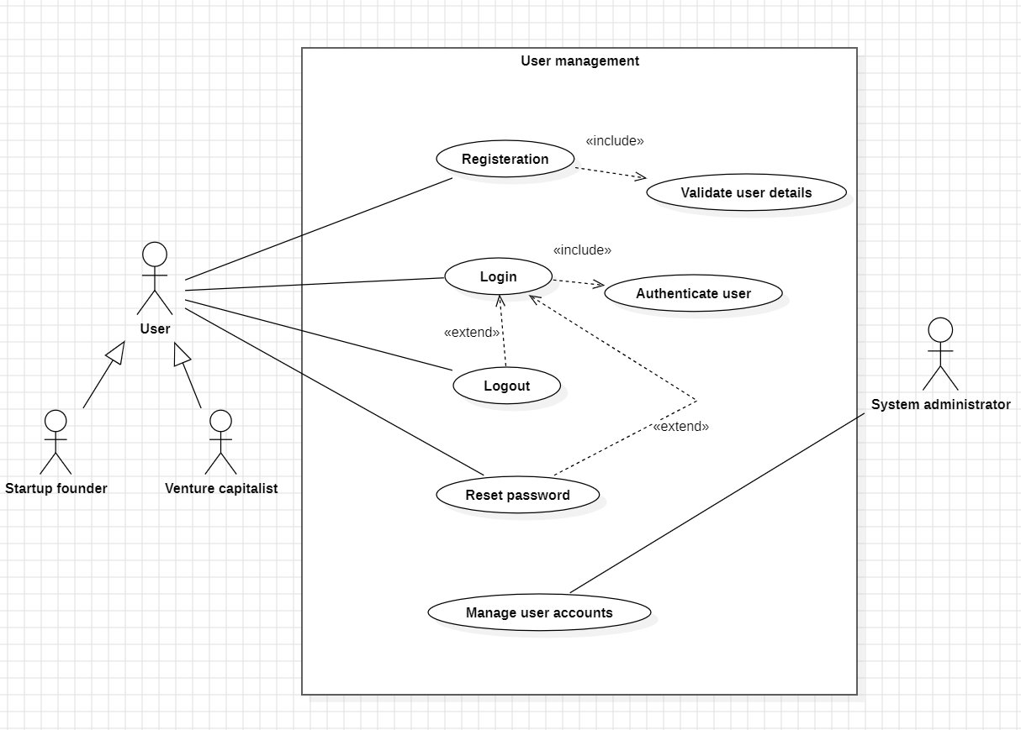

- Startup’s profile management module
The Startup Module is designed for startup founders to manage their startup-related information. Through this module, startups can create and update their startup profiles, upload pitch decks, and submit funding requirements. This module helps startups present their ideas in a structured and professional manner. The information provided through this module is visible to venture capitalists for evaluation.

Primary actors:
- Startup founder
Secondary actors:
- Venture capitalist
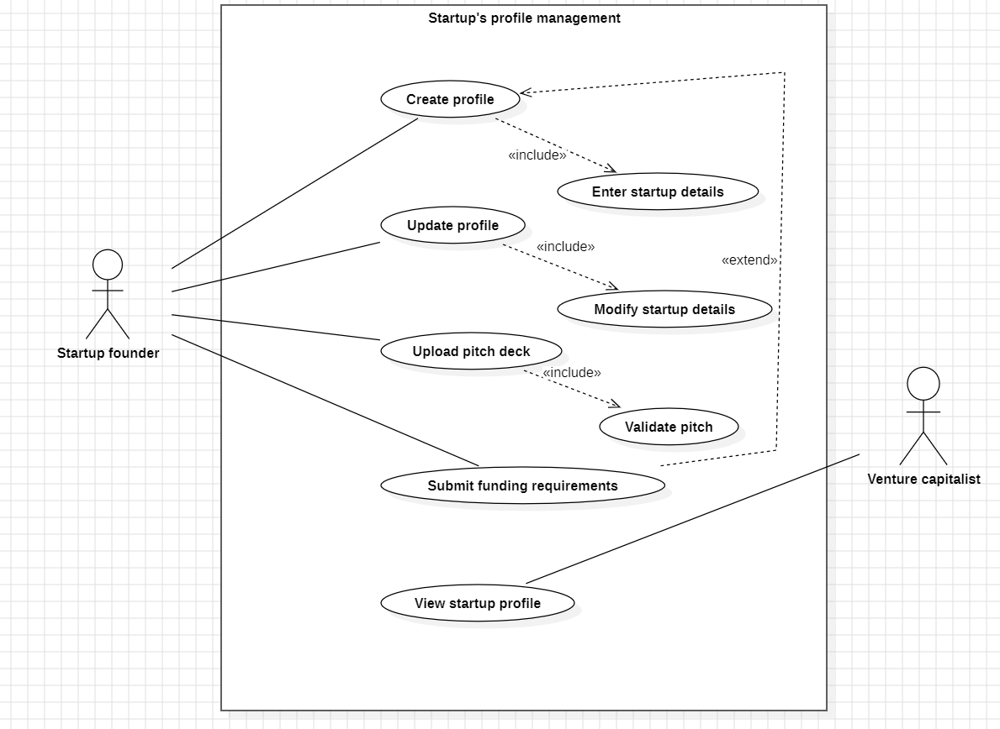

- Venture capitalist’s profile management module
The Venture Capitalist Module allows users who act as investors to create and manage their venture capitalist profiles. Using this module, venture capitalists can search for startups, filter them based on their interests, and view startup profiles along with pitch decks. This module helps investors evaluate startups efficiently and decide whether to proceed with further discussions or investments.

Primary actors:
- Venture capitalist

Secondary actors:
- Startup founder
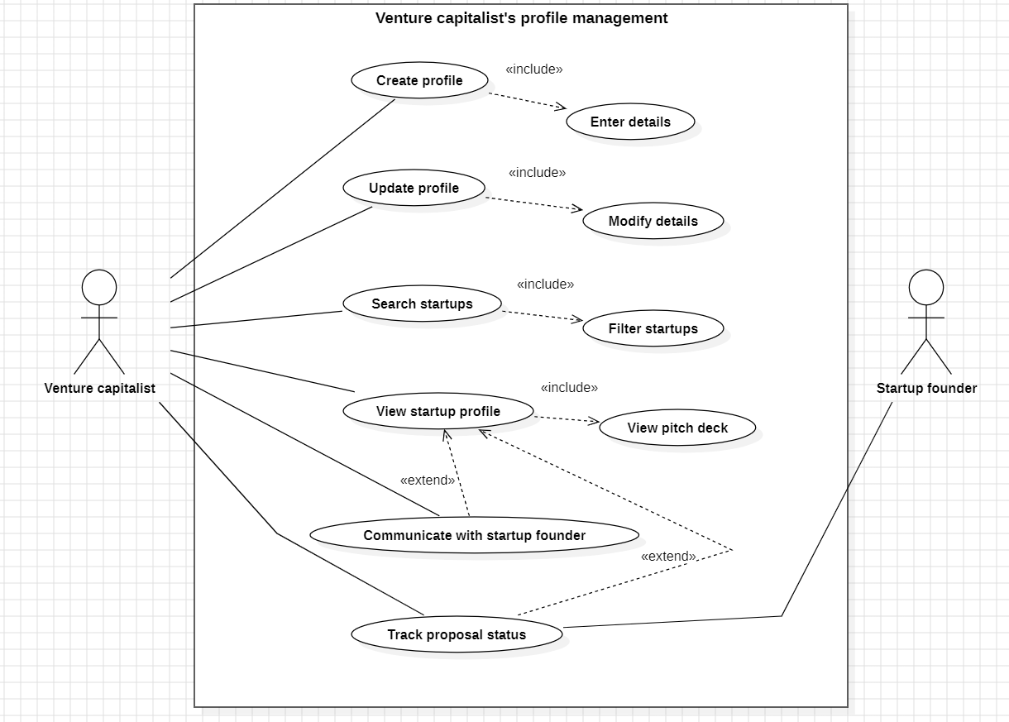
- Communicating via software module
The Communication Module enables direct interaction between startup founders and venture capitalists. It allows both parties to send, receive, and respond to messages within the system. This module reduces dependency on emails and helps keep all discussions organized and easy to track. Notifications are also provided to inform users about new messages.

Primary actors:
- Venture capitalist
- Startup founder
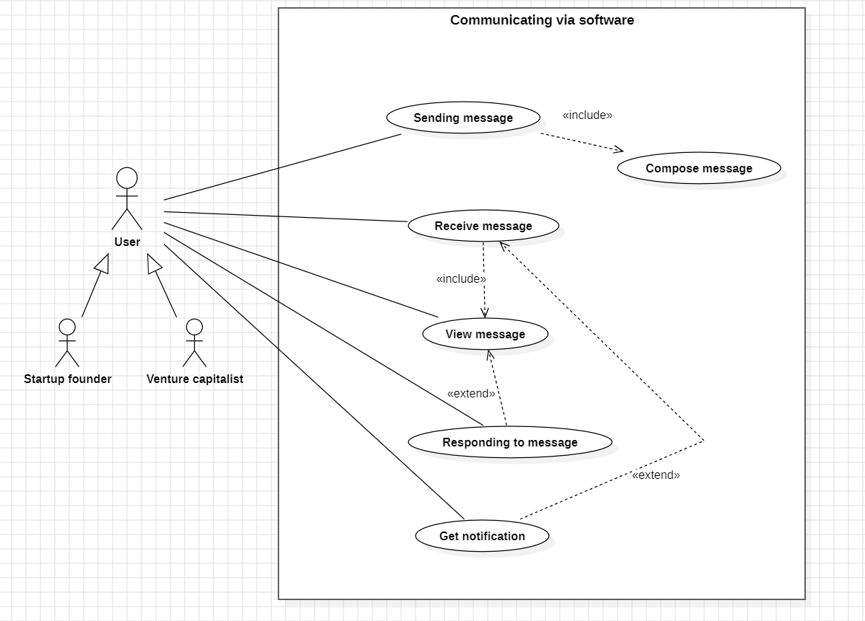
- Proposal and fund tracking module
The Proposal and Funding Tracking Module manages the submission and tracking of funding proposals. Startups can submit funding proposals, and venture capitalists can review and update the proposal status. Both parties can track the current status of proposals and funding progress. This module helps maintain transparency and avoids confusion during funding discussions.

Primary actors:
- Venture capitalist
- Startup founder

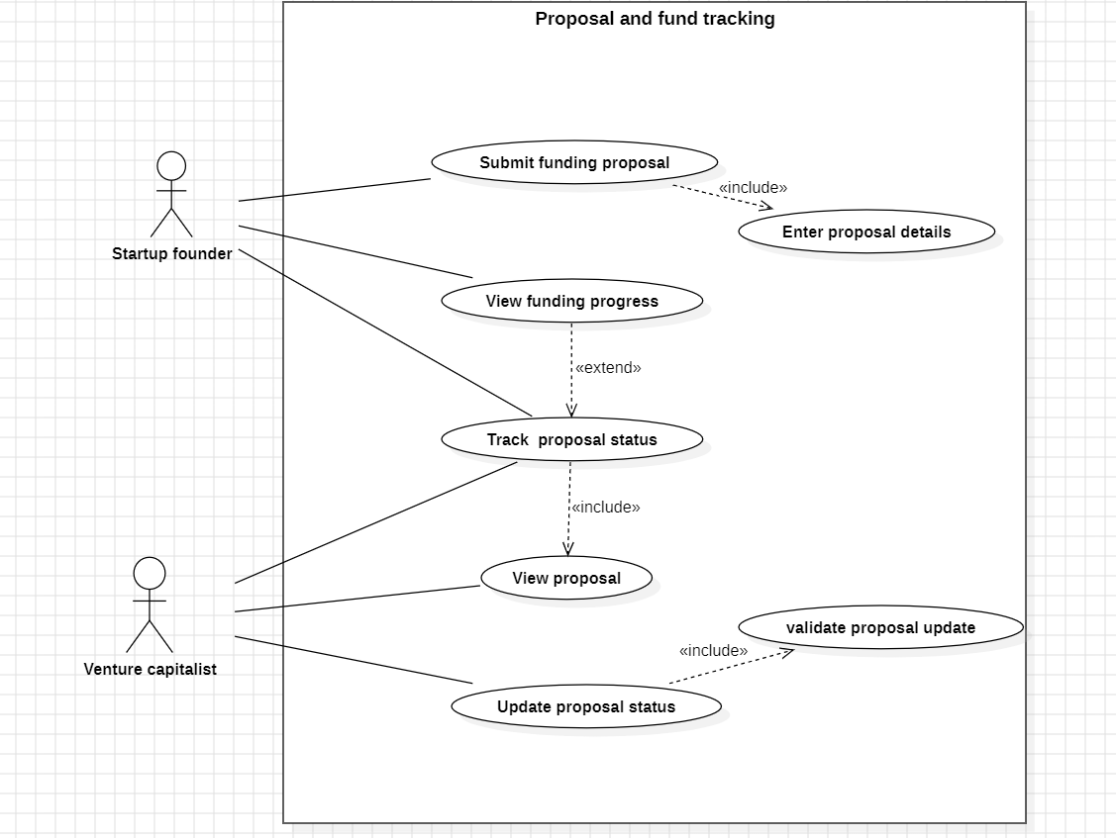
- Admin management module
The Admin Module is used by the system administrator to monitor and manage the overall system. It allows the admin to view user details, approve or block users, and monitor system activities. The admin can also view reports related to system usage. This module ensures that the system operates smoothly and securely.

Primary actors:
- System administrator

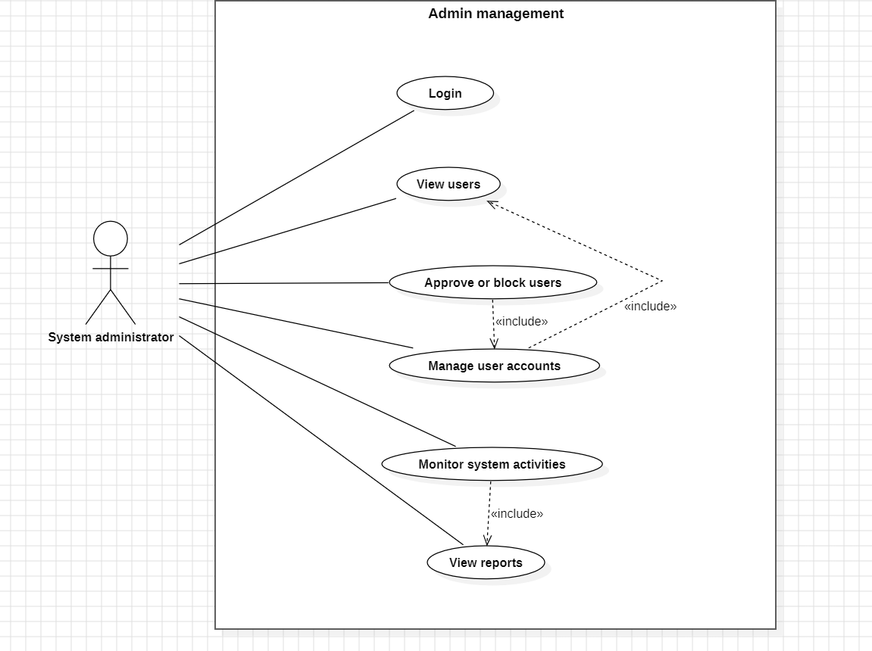
Class diagrams
i) User management module
The User Management class diagram represents the basic structure of users in the system. The User class acts as the base class containing common attributes such as user ID, name, email, and password, along with login and logout operations.TheStartupFounder, VentureCapitalist, and Admin classes inherit from the User class, showing that all are types of users. Each derived class has its own unique identifier and operations related to its role. This design avoids duplication of common user information and supports role-based functionality in the system.

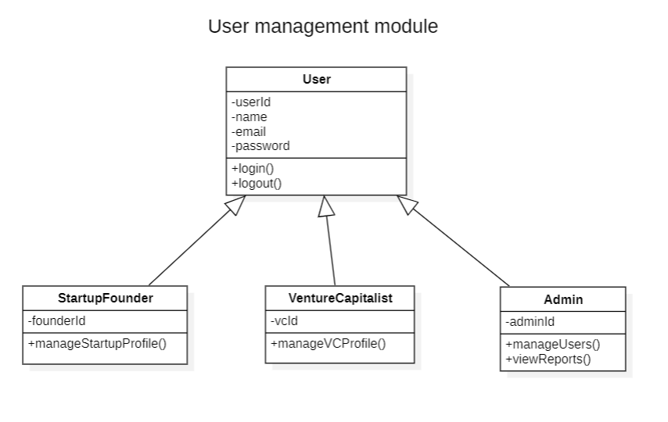

ii) Startup’s profile management module
The Startup Module class diagram shows how startup-related information is managed in the system. A StartupFounder creates and manages a StartupProfile, which stores essential information about the startup such as description and team details.
Each StartupProfile is associated with exactly one Startup, which holds core startup details like name, domain, and funding stage. The StartupProfile may also have an associated PitchDeck, which represents the presentation uploaded by the startup. This structure ensures that startup information is organized and easily accessible to investors.
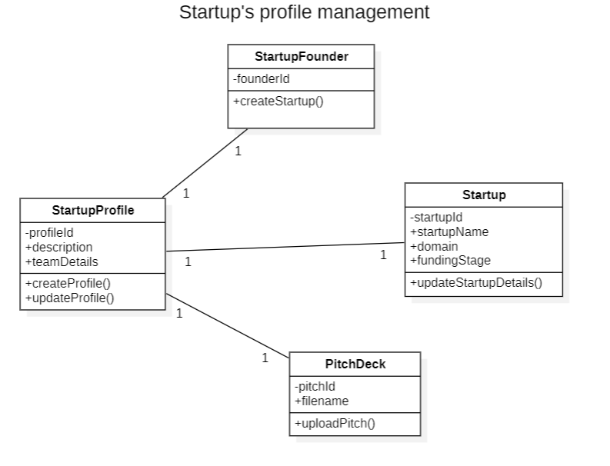

iii) Venture capitalist’s profile management module
The Venture Capitalist Module class diagram represents how investors manage their profiles. The VentureCapitalist class is associated with a VCProfile, which contains details such as experience and investment domain.
Each venture capitalist has exactly one VCProfile, which helps the system identify investor preferences and interests. This separation allows investor-specific information to be managed independently while still linking it to the main user entity.

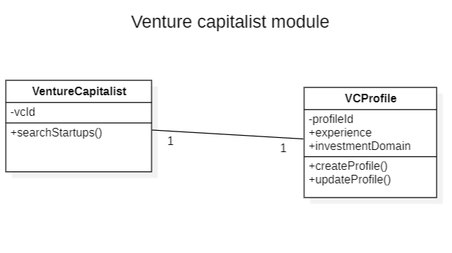
iv) Communicating via software module
The Communication Module class diagram illustrates how messaging works between startups and venture capitalists. Both StartupFounder and VentureCapitalist classes are associated with the Message class, indicating that both parties can send and receive multiple messages.
Each Message contains content and timestamp information. A message may generate a Notification, which alerts users about new messages. This design supports organized and traceable communication within the system.

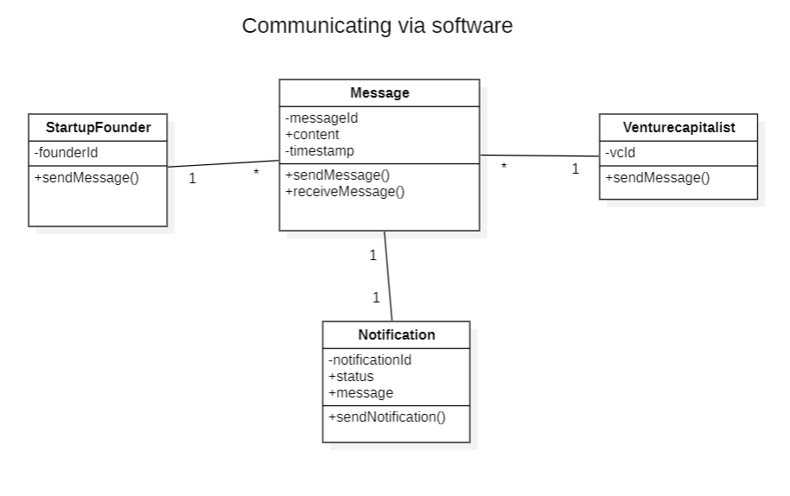
v) Proposal and fund tracking module
The Proposal and Funding Module class diagram explains the process of funding requests and investment tracking. A StartupProfile can submit multiple Proposals, each containing requested funding amount and status.
A VentureCapitalist can review multiple proposals and update their status. Each Proposal may lead to a Funding entity, which stores details such as funded amount and funding stage. This structure ensures clear tracking of proposals from submission to funding.

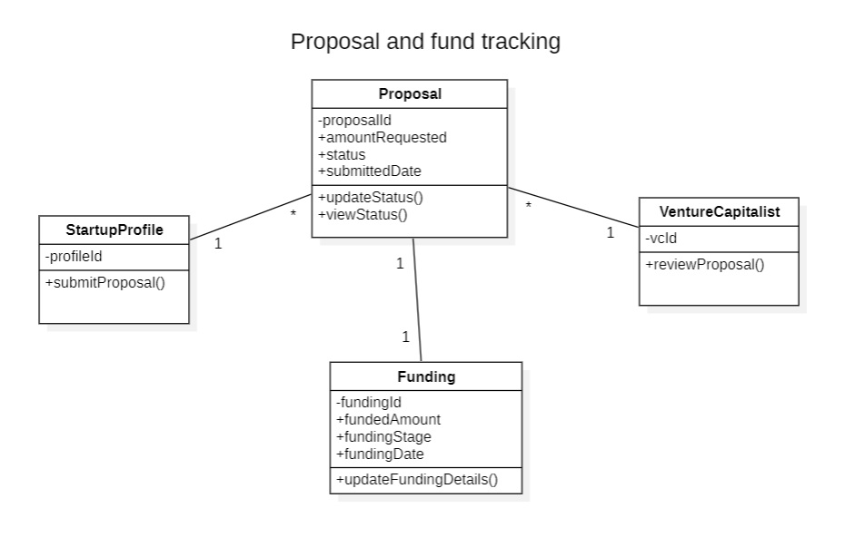
vi) Admin management module
The Admin Module class diagram represents system administration activities. The Admin class manages multiple User accounts in the system. The admin can perform operations such as managing users, blocking users, and monitoring system activity.
This module ensures system security and proper functioning by allowing administrative control over users and system operations.
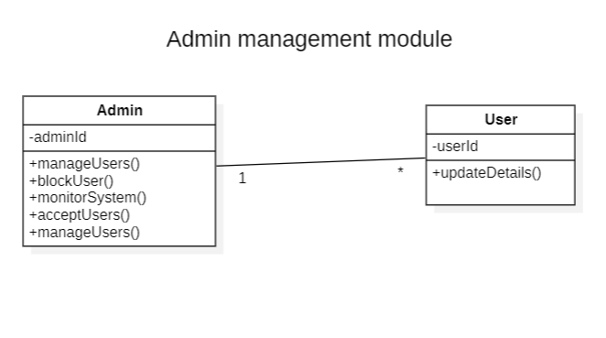

State Diagrams
I selected module-v to draw state diagrams, each class is drawn as separate state diagram
- StartupProfile
This diagram shows how a startup profile is created, updated, pitch deck uploaded, activated, and finally deactivated.

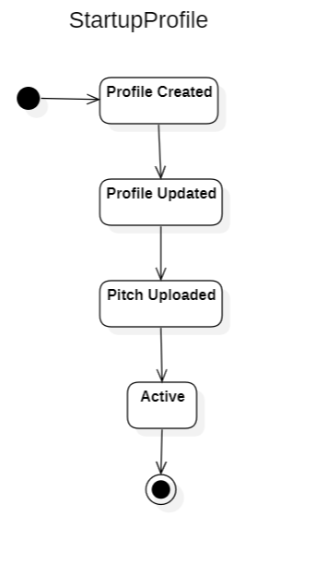

- VentureCapitalist
This state diagram represents the lifecycle of a venture capitalist from registration to account deactivation.
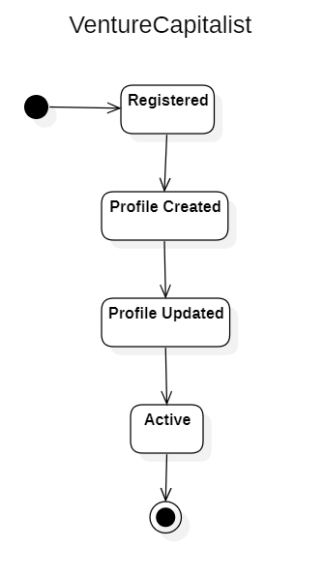

- Proposal
This state diagram shows the complete lifecycle of a proposal from creation, review, revision, approval or rejection, and finally funding.

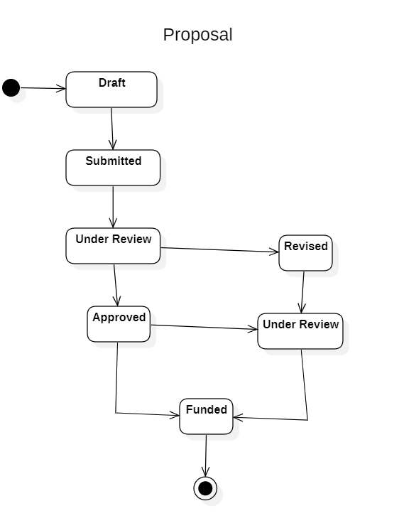
- Funding
This state diagram illustrates the steps involved in funding, from initiation to completion and closure.

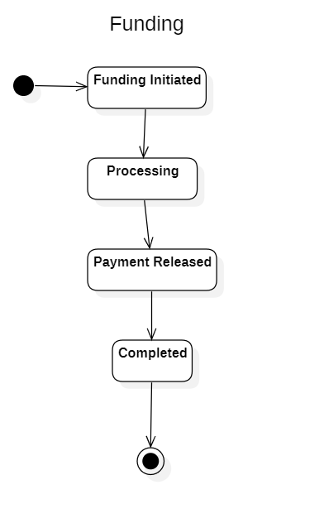

Activity Diagrams

- Startup Founder
This activity diagram represents the workflow followed by a startup founder in the system. The process starts with user login, after which the founder creates or updates the startup profile. The founder then uploads the pitch deck and submits funding requirements. Once the proposal is submitted, the startup founder waits for investor responses and communicates with venture capitalists if needed. Finally, the founder tracks the proposal status and funding progress before logging out of the system.

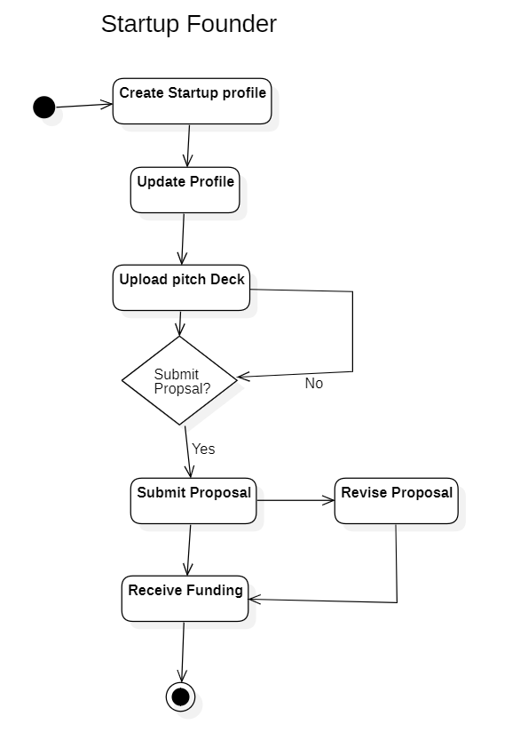

- Venture Capitalist
This activity diagram illustrates the steps performed by a venture capitalist. After logging in, the venture capitalist searches and filters startups based on investment interests. The investor then views startup profiles and pitch decks. If interested, the venture capitalist communicates with the startup founder and reviews the funding proposal. Based on evaluation, the proposal is either approved or rejected. The venture capitalist can track proposal progress and then logs out of the system.

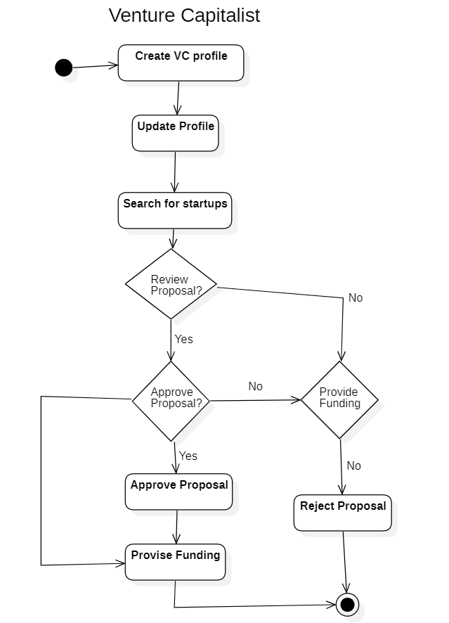

Sequence Diagram

- User management module
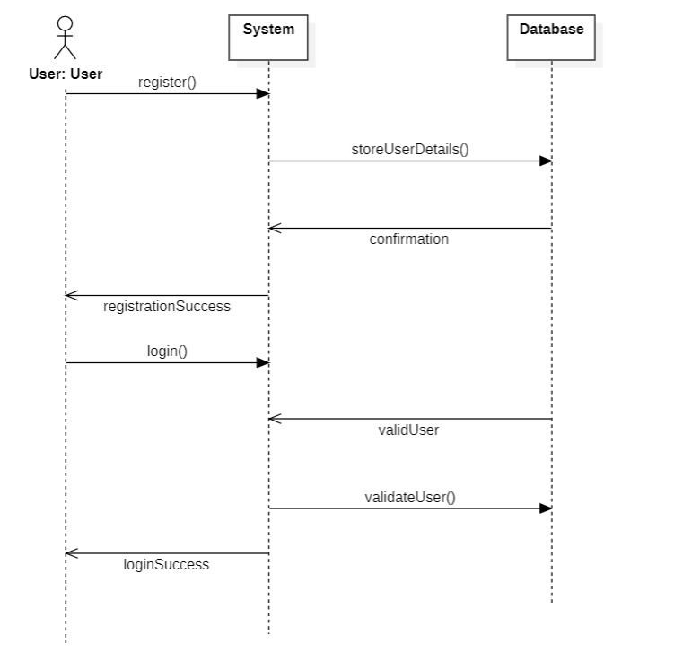
- StartupFounder module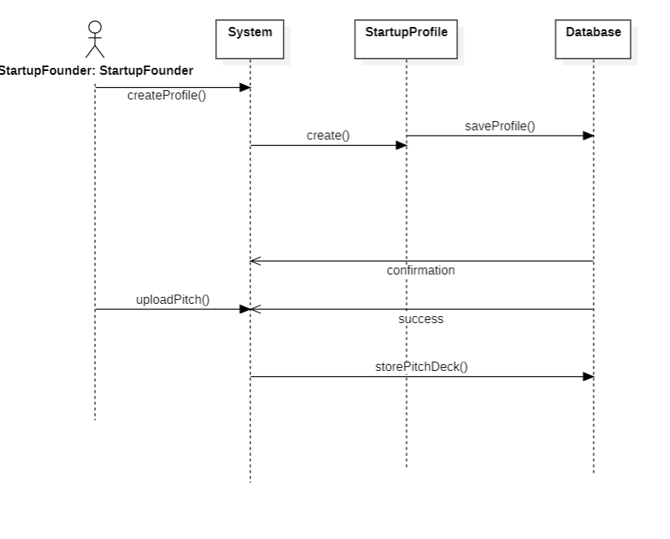

- Venture Capitalist module
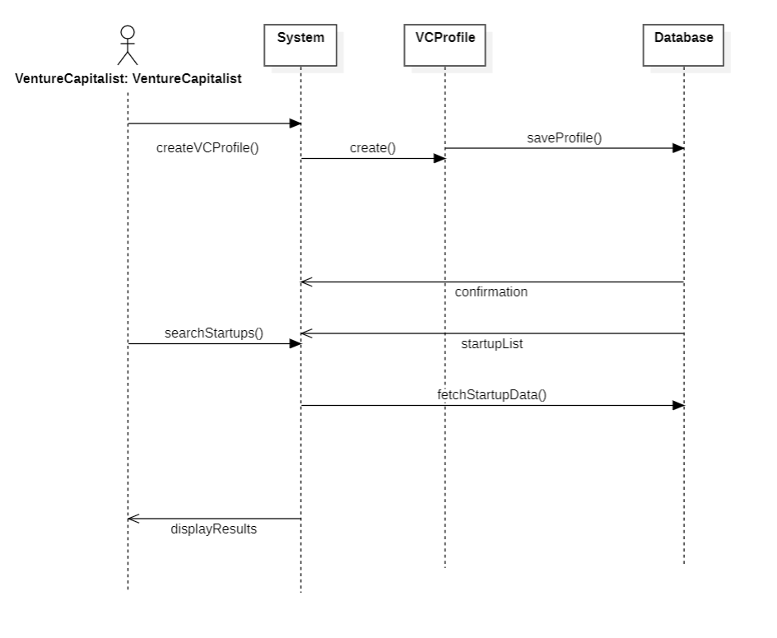

- Communicating module
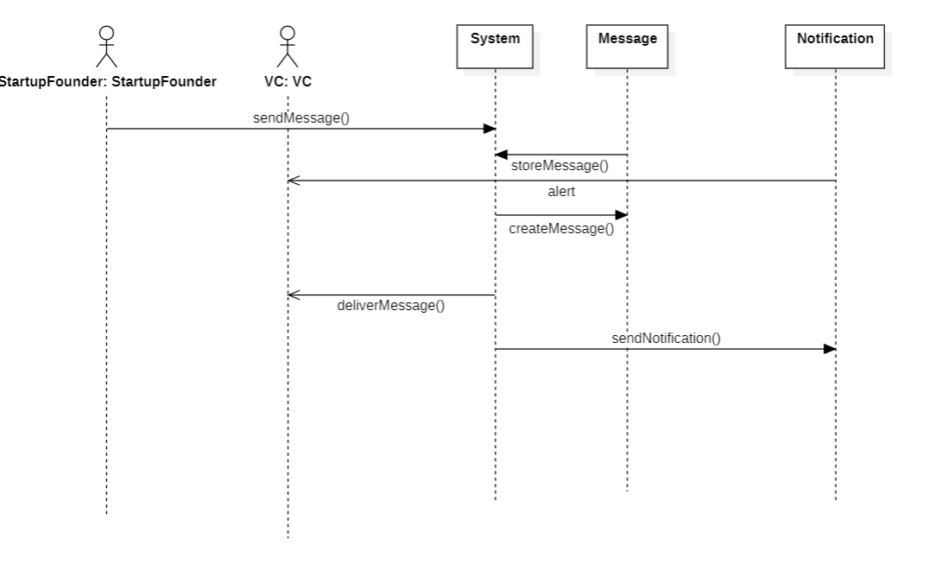
- Proposal and funding module
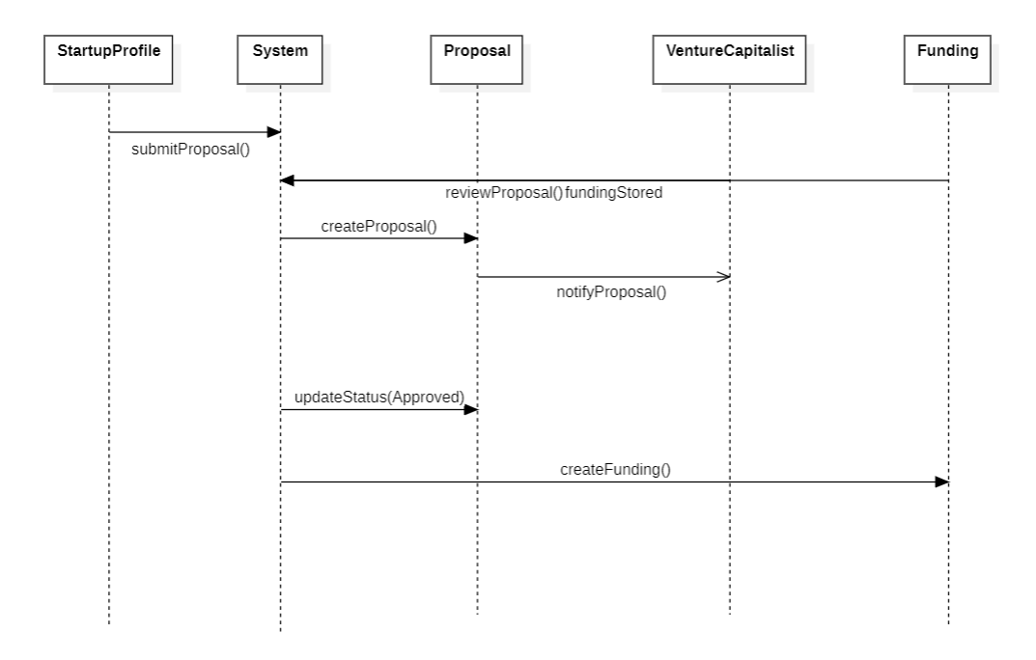

- Admin module
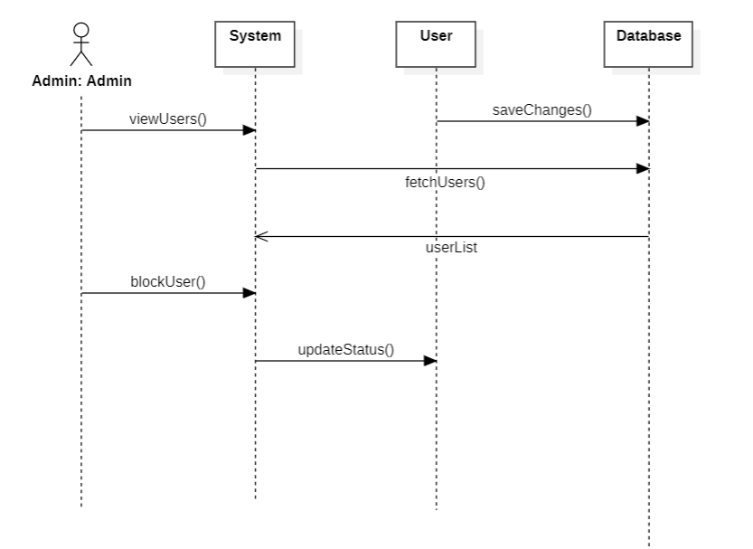

Collaboration diagrams
- User management module
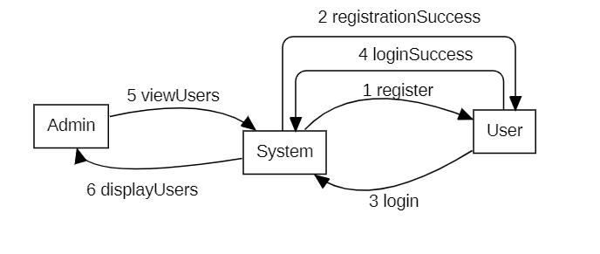
- Startup Founder module
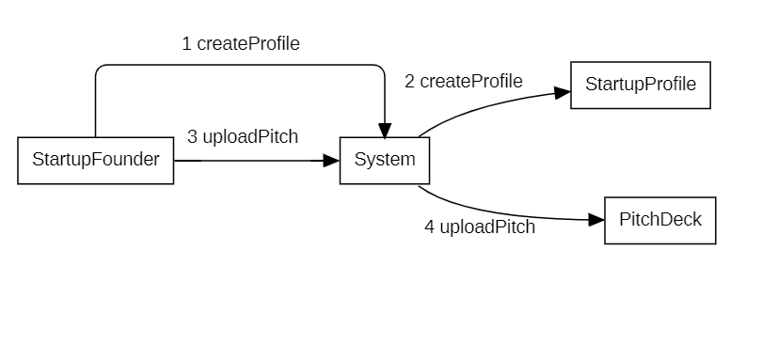
- Venture Capitalist module
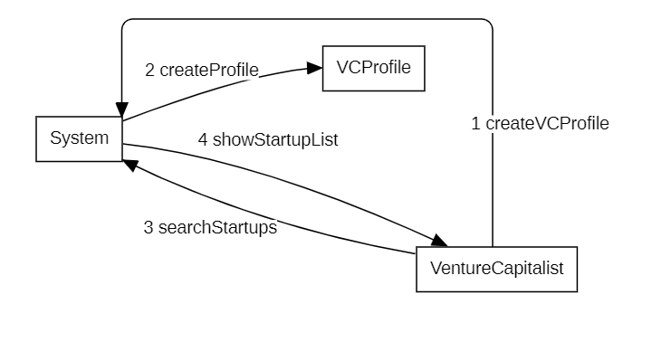
- Communication module
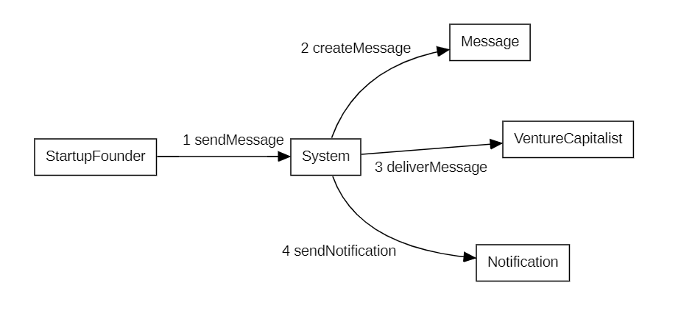
- Proposal and funding module
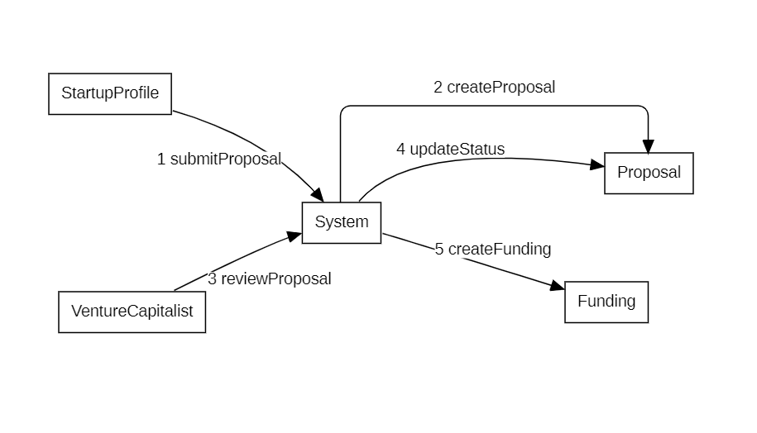

- Admin module
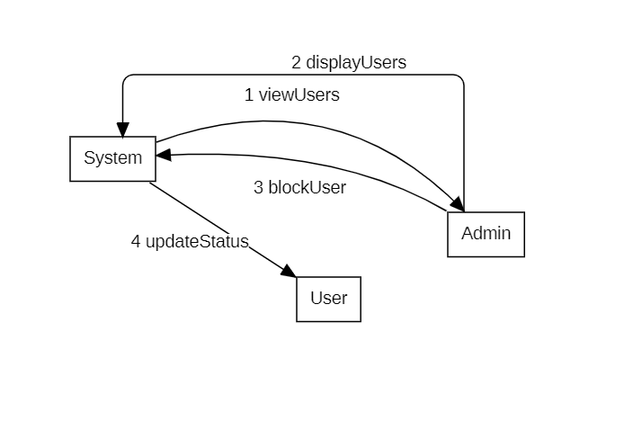

3.2 ER Diagrams

Entities and Attributes

User:
- userId (PK)
- name
- email
- password
- role

StartupProfile:
- profileId (PK)
- startupName
- domain
- fundingStage
- description
- userId (FK)

PitchDeck:
- pitchId (PK)
- fileName
- uploadDate
- profileId (FK)

VentureCapitalistProfile:
- vcProfileId (PK)
- firmName
- investmentDomain
- experience
- userId (FK)

Proposal:
- proposalId (PK)
- amountRequested
- status
- submittedDate
- profileId (FK)
- vcProfileId (FK)
Funding:
- fundingId (PK)
- fundedAmount
- fundingStage
- proposalId (FK)

Message:
- messageId (PK)
- content
- timestamp
- senderId (FK)
- receiverId (FK)

Notification:
- notificationId (PK)
- message
- status
- messageId (FK)

Relationships (With Cardinality)
Relationship | Cardinality
User — StartupProfile | 1 :0..1
StartupProfile — PitchDeck | 1 :0..1
User — VentureCapitalistProfile | 1 :0..1
StartupProfile — Proposal | 1 :0..*
VentureCapitalistProfile — Proposal | 1 :0..*
Proposal — Funding | 1 :0..1
User — Message (sender) | 1 :0..*
User — Message (receiver) | 1 :0..*
Message — Notification | 1 :0..1

The ER diagram represents the database structure of the Startup–Venture Capital Interaction System. It shows entities such as User, StartupProfile, VentureCapitalistProfile, Proposal, and Funding along with their attributes and relationships. The diagram explains how startups submit proposals, venture capitalists review them, and funding is managed, along with communication and notifications.

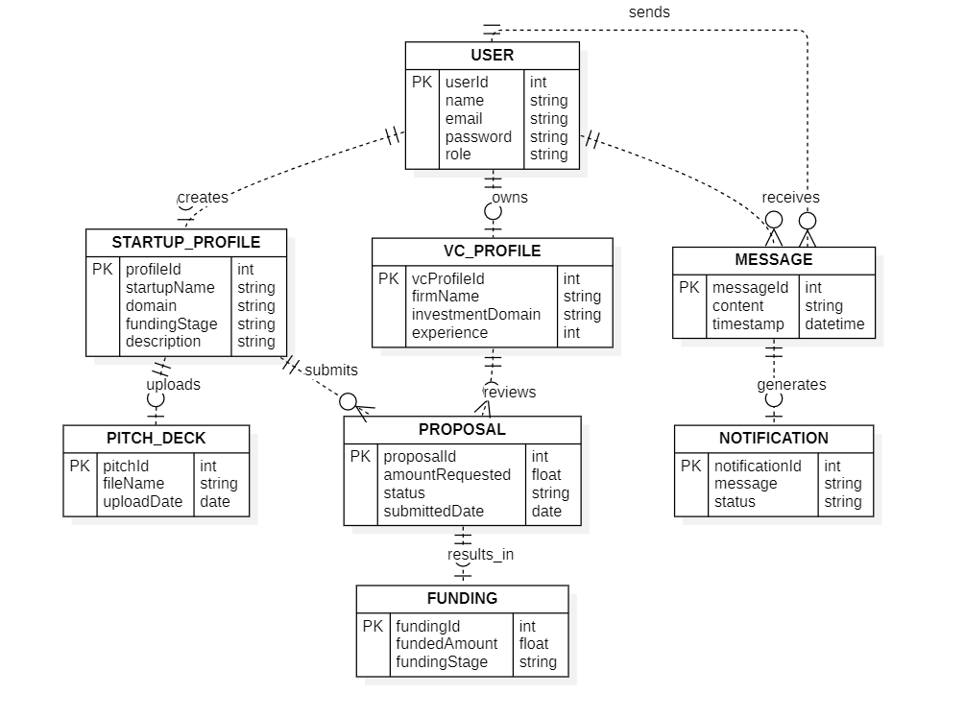
3.3 DFD Diagrams
This diagram shows the Startup–Venture Capital Interaction System as a single process and represents how startup founders, venture capitalists, and administrators interact with the system through data flows and a central data store.

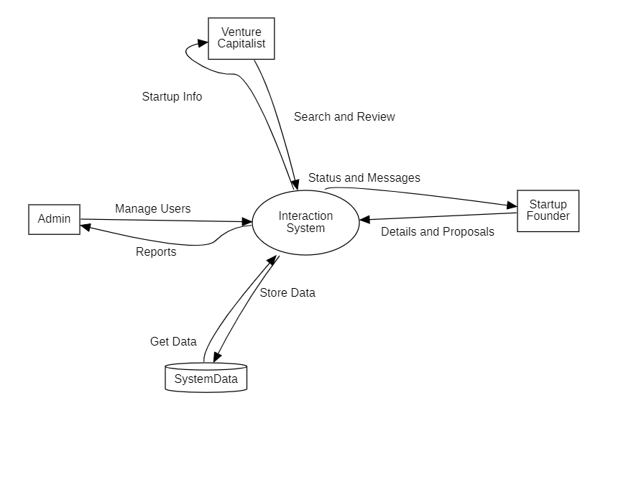

4. External Interface Requirements / Screenshots
This section describes how the software interacts with users, hardware, software, and communication mechanisms.

4.1 User Interfaces
The system provides a web-based user interface that can be accessed using standard web browsers.
Different interfaces are provided based on the user role.
- Startup Founder Interface
  - User registration and login screens
  - Startup profile creation and update pages
  - Pitch deck upload interface
  - Proposal submission and status tracking pages
  - Messaging interface to communicate with venture capitalists
- Venture Capitalist Interface
  - Login and profile management screens
  - Startup search and filter interface
  - Startup profile and pitch deck viewing pages
  - Proposal review and decision interface
  - Messaging interface to communicate with startup founders
- Admin Interface
  - User management dashboard
  - User monitoring and blocking interface
  - Report viewing interface
The user interface is designed to be simple, intuitive, and user-friendly.

4.2 Hardware Interfaces
The system does not require any special hardware components.
- Users can access the system using:
  - Desktop computers
  - Laptops
  - Tablets or smartphones
- Minimum hardware requirements:
  - Internet-enabled device
  - Basic input devices such as keyboard, mouse, or touch screen
All processing is handled on the server side.

4.3 Software Interfaces
The software interacts with the following software components:
- Web browsers such as:
  - Google Chrome
  - Mozilla Firefox
  - Microsoft Edge
- Operating systems:
  - Windows
  - Linux
  - macOS
The system may use:
- A web server
- An application server
- A database management system (internally)
These software components support storage, processing, and retrieval of data.

4.4 Communication Interfaces
The system communicates using standard internet communication protocols.
- Communication is done through:
  - HTTP / HTTPS protocols
- Secure communication is ensured using HTTPS.
- Email or notification services may be used to send alerts and updates to users.
The system supports communication between startup founders and venture capitalists through an internal messaging mechanism.

5. Other Non-Functional Requirements
This section describes the quality and operational requirements of the system.

5.1 Performance Requirements
- The system should respond to user requests within an acceptable time.
- Normal operations such as login, profile viewing, and messaging should load quickly.
- The system should support multiple users accessing it simultaneously without performance degradation.

5.2 Safety Requirements
- The system does not involve any physical safety risks.
- Proper error handling should be implemented to avoid system crashes.
- User actions should not result in data loss due to system failures.

5.3 Security Requirements
- User authentication is required to access the system.
- Passwords must be stored securely.
- Users can access only the data permitted by their role.
- Admin privileges are restricted to authorized administrators only.
- Secure communication channels are used to protect data.

5.4 Software Quality Attributes
The software should satisfy the following quality attributes:
- Usability: Easy to use and understand for all user types
- Reliability: System should function correctly under normal conditions
- Scalability: Can support an increasing number of users in the future
- Maintainability: Easy to update and enhance
- Availability: System should be available whenever users need it

5.5 Business Policies / Rules (if any)
- A startup must create a profile before submitting proposals.
- Venture capitalists can view startup details only after logging in.
- Proposals can be reviewed and updated only by authorized venture capitalists.
- Admin has the authority to manage and block users if required.
- Communication between users must follow platform rules and policies.
6.Testing:
- Code Snippet -1: User Validation
def validate_user(username, password, email):

if username == "":
return "Username empty"

if len(password) < 6:
return "Password too short"

if "@" not in email:
return "Invalid email"

return "User valid"

6.1 White Box Testing:
- Control Flow Graph:
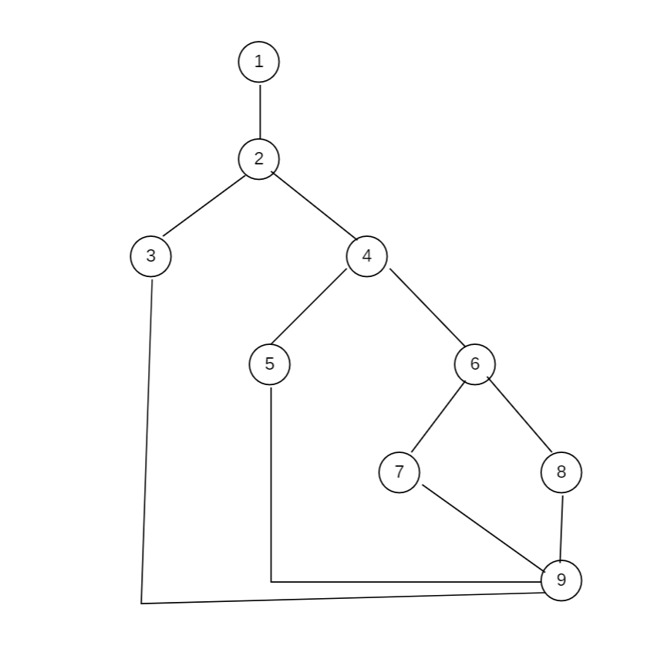

- Cyclomatic Complexity:
Method-1: Total number of inner regions + Outer region = 4
Method-2: Using Edges and Nodes; V(G) = E – N + 2
Here N=9, E=11
V(G) = 11 – 9 + 2 = 4
Method-3: Using Decision (Predicate) Nodes; V(G) = P + 1
V(G) = 3+1 = 4

- Independent Program Paths:
- Path1 (Username empty): 1,2,3,9
- Path2 (Password too short): 1,2,4,5,9
- Path3 (Invalid email): 1,2,4,6,7,9
- Path4 (User valid): 1,2,4,6,8,9
- Test Cases:
Path No. | Independent Path (Node Sequence) | Test Input | Expected Output
P1 | 1,2,3,9 | ("", "123456", "priya@gmail.com") | Username empty
P2 | 1,2,4,5,9 | ("priya", "123", "priya@gmail.com") | Password too short
P3 | 1,2,4,6,7,9 | ("priya", "123456", "priyamail.com") | Invalid email
P4 | 1,2,4,6,8,9 | ("priya", "123456", "priya@gmail.com") | User valid

- Execution:
def validate_user(username, password, email):
if username == "":
return "Username empty"
if len(password) < 6:
return "Password too short"
if "@" not in email:
return "Invalid email"
return "User valid"
import unittest
class TestValidateUser(unittest.TestCase):
def test_username_empty(self):
self.assertEqual(validate_user("", "123456", "priya@gmail.com"), "Username empty")
def test_password_short(self):
self.assertEqual(validate_user("priya", "12345", "priya@gmail.com"), "Password too short")
def test_invalid_email(self):
self.assertEqual(validate_user("priya", "123456", "priyagmail.com"), "Invalid email")
def test_valid_user(self):
self.assertEqual(validate_user("priya", "123456", "priya@gmail.com"), "User valid")
if __name__ == "__main__":
unittest.main()
Output:
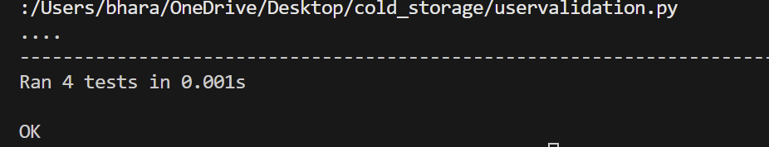
6.2 Black Box Testing:
Functional Requirements:
- For validate_user() module
- Username should not be empty
- Password length must be ≥ 6 characters
- Email must contain @
- If all inputs are valid → return "User valid"

- Equivalence Partitioning:
Username:
Class | Input | Type
EC1 | “ ” | Invalid
EC2 | Non-empty username | Valid
Password:
Class | Range | Type
EC3 | Length<6 | Invalid
EC4 | Length>=6 | Valid
Email:
Class | Range | Type
EC5 | without@ | Invalid
EC6 | contains@ | Valid

- Boundary Value Analysis:
Boundary for password=6 characters
Test | Input | Expected Output
B1 | ("priya", "12345", "priya@gmail.com") | Password too short
B2 | ("priya", "123456", "priya@gmail.com") | User valid
B3 | ("priya", "1234567", "priya@gmail.com") | User valid

- Example execution:
- print(validate_user("", "123456", "priya@gmail.com"))
- print(validate_user("priya", "12345", "priya@gmail.com"))
- print(validate_user("priya", "123456", "priyagmail.com"))
- print(validate_user("priya", "123456", "priya@gmail.com"))

- Expected outcome:
- Username empty
- Password too short
- Invalid email
- User valid

- Code Snippet -2: Proposal evaluation
def evaluate_proposal(amount, stage):
if amount <= 0:
return "Invalid amount"
if stage == "idea" and amount > 100000:
return "Rejected"
if stage == "prototype" and amount <= 500000:
return "Approved"
if stage == "growth":
return "Approved"
return "Under review"
6.1 White Box Testing:
- Control Flow Graph:
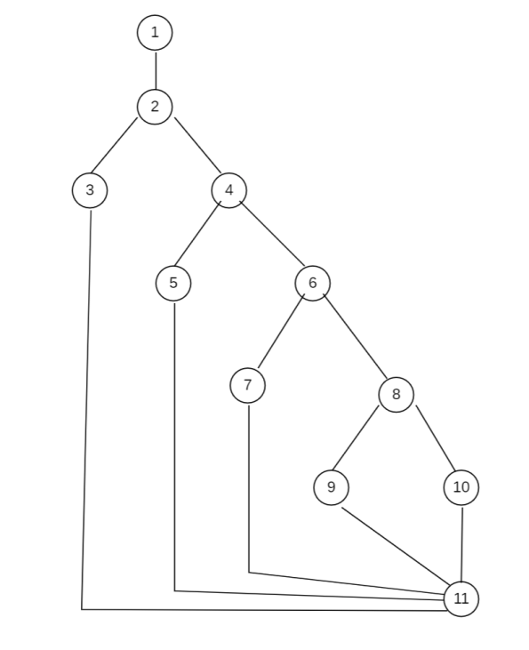

- Cyclomatic Complexity:
Method-1: Total number of inner regions + Outer region = 5
Method-2: Using Edges and Nodes; V(G) = E – N + 2
Here N=11, E=14
V(G) = 14 – 11 + 2 = 5
Method-3: Using Decision (Predicate) Nodes; V(G) = P + 1
V(G) = 4+1 = 5

- Independent Program Paths:
- Path1 (Invalid amount): 1,2,3,11
- Path2 (Rejected): 1,2,4,5,11
- Path3 (Under review): 1,2,4,6,7,11
- Path4 (Approved): 1,2,4,6,8,9,11
- Path5 (Under review): 1,2,4,6,8,10,11

- Test Cases:
Path No. | Independent Path (Node Sequence) | Test Input | Expected Output
P1 | 1,2,3,11 | (-100, "idea") | Invalid amount
P2 | 1,2,4,5,11 | (200000, "idea") | Rejected
P3 | 1,2,4,6,7,11 | (50000, "idea") | Under review
P4 | 1,2,4,6,8,9,11 | (300000, "prototype") | Approved
P5 | 1,2,4,6,8,10,11 | (600000, "prototype") | Under review

- Execution:
def evaluate_proposal(amount, stage):
if amount <= 0:
return "Invalid amount"
if stage == "idea" and amount > 100000:
return "Rejected"
if stage == "prototype" and amount <= 500000:
return "Approved"
if stage == "growth":
return "Approved"
return "Under review"

import unittest
class TestEvaluateProposal(unittest.TestCase):
def test_invalid_amount(self):
self.assertEqual(evaluate_proposal(-100, "idea"), "Invalid amount")
def test_idea_rejected(self):
self.assertEqual(evaluate_proposal(200000, "idea"), "Rejected")
def test_idea_under_review(self):
self.assertEqual(evaluate_proposal(50000, "idea"), "Under review")
def test_prototype_approved(self):
self.assertEqual(evaluate_proposal(300000, "prototype"), "Approved")
def test_prototype_under_review(self):
self.assertEqual(evaluate_proposal(600000, "prototype"), "Under review")
if __name__ == "__main__":
unittest.main()
Output:
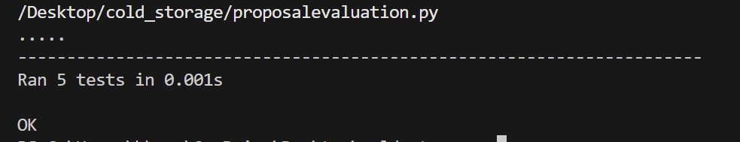
6.2 Black Box Testing:
Functional Requirements:
For evaluate_proposal() module
- Funding amount must be greater than 0
- If stage = idea and amount > 100000 → Rejected
- If stage = prototype and amount ≤ 500000 → Approved
- If stage = growth → Approved
- Otherwise → Under review

- Equivalence Partitioning:
Funding amount:
Class | Input | Type
EC1 | Amount<=0 | Invalid
EC2 | Amount>0 | Valid

Startup Stage:
Class | Stage | Output
EC3 | idea | Under review/Rejected
EC4 | prototype | Approved
EC5 | growth | Approved

- Boundary Value Analysis:
Idea Stage Boundary(100000)
B No | Test Input | Expected Output | Technique
BB4 | (99999,"idea") | Under review | 100000-1
BB5 | (100000,"idea") | Under review | 100000
BB6 | (100001,"idea") | Rejected | 100000+1

Prototype Stage Boundary(500000)
B No | Test Input | Expected Output | Technique
BB7 | (499999,"prototype") | Approved | 500000-1
BB8 | (500000,"prototype") | Approved | 500000
BB9 | (500001,"prototype") | Under review | 500000+1

- Example execution:
- print(evaluate_proposal(-100,"idea"))
- print(evaluate_proposal(200000,"idea"))
- print(evaluate_proposal(50000,"idea"))
- print(evaluate_proposal(300000,"prototype"))
- print(evaluate_proposal(600000,"prototype"))

- Expected outcome:
- Invalid amount
- Rejected
- Under review
- Approved
- Under review

7.Conclusion:
The Startup–Venture Capital Interaction System is designed to make the process of connecting startups and investors easier and more organized. Startups can create profiles, upload their pitch decks, and submit funding proposals, while venture capitalists can explore startup ideas, review proposals, and communicate with founders through the platform.
While preparing this SRS document, the system requirements were analyzed and clearly defined. Different diagrams such as UML diagrams, ER diagrams, and DFD diagrams were created to understand how the system will work and how different components interact with each other. Testing methods such as black box and white box testing were also considered to ensure that the system functions correctly.
Overall, the system aims to reduce the difficulties faced by startups in finding investors and also helps venture capitalists discover suitable startup ideas more efficiently. In the future, the system can be improved by adding more features like recommendation systems, better security, and advanced data analysis tools.

8.References
- Sommerville, Ian. Software Engineering, 10th Edition, Pearson Education.
- Pressman, Roger S. Software Engineering: A Practitioner’s Approach, McGraw-Hill.
- IEEE Software Requirements Specification (SRS) documentation guidelines.
- Lecture notes and study material from the Software Engineering course.
- Python official documentation – https://docs.python.org⁠

9.Acknowledgements
I would like to thank our instructor for the guidance and support provided during the development of this project. The explanations and suggestions helped in understanding the concepts related to software requirements and system design.
I also thank my college for providing the learning environment and resources needed to complete this work. Lastly, I would like to acknowledge the textbooks, online materials, and documentation that helped me understand the topic better while preparing this report.

DESIGN MODELS

- Component level diagram
The component diagram illustrates the major components of the system and the interfaces through which they interact. Each component represents a functional module responsible for handling specific tasks such as user management, startup management, proposal processing, and communication services.

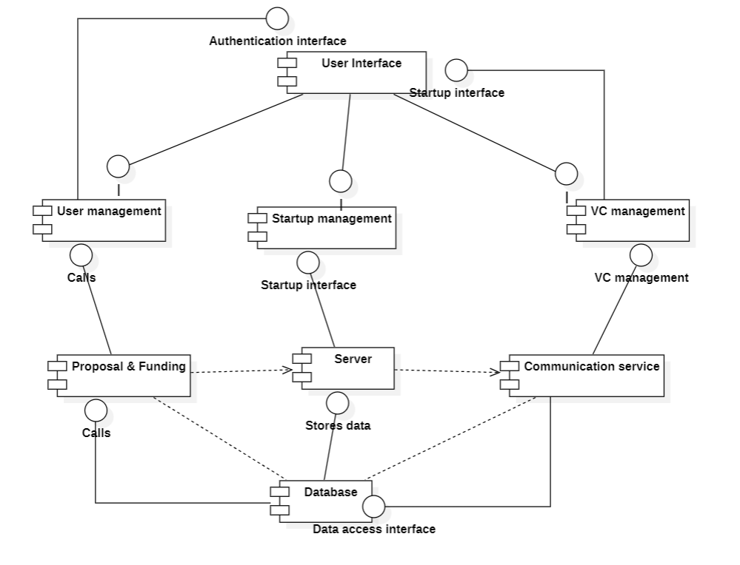

- Deployment level diagram
The deployment diagram shows the physical architecture of the system and how software components are deployed on hardware nodes. Users access the system through a web browser on their devices, which communicates with the web server hosting the application. The application interacts with the database server to store and retrieve system data.
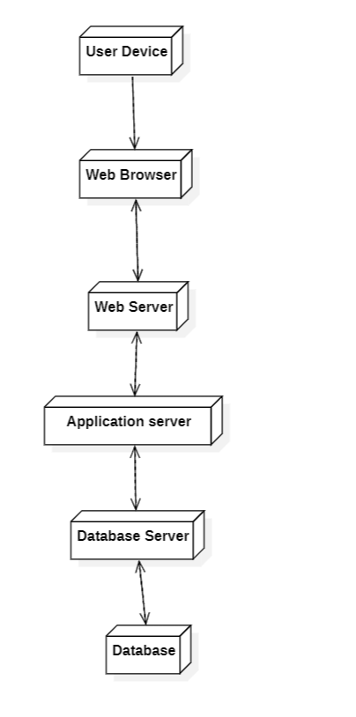

PRODUCT METRICS FOR ANALYSIS MODEL

FUNCTIONAL POINT ANALYSIS OF STARTUP-VENTURE CAPITAL INTERACTION SYSTEM
1. Calculation of Function Point:

- Calculation of UFP (Unadjusted Functional Point):

Information Domain Value | Count | Weightage Factor |  |  | Individual Sum | Sum
 |  | Simple | Average | Complex
External Inputs (EIs) | 4 | 3 | 4 | 6 | 4x4 | 16
External Outputs (EOs) | 3 | 4 | 5 | 7 | 3x5 | 15
External Inquiries (EIs) | 3 | 3 | 4 | 6 | 3x4 | 12
Internal Logical Files (ILFs) | 4 | 7 | 10 | 15 | 4x15 | 60
External Interface Files (EIFs) | 1 | 5 | 7 | 10 | 1x5 | 5
Total Sum |  |  |  |  |  | 108

Unadjusted Functional Point value = 108

B.Calculation of CAF (Complexity Adjustment Factor):

S.No. | Questions | Rating
1. | Does the system require a reliable backup and recovery? | 4
2. | Are specialized data communications required to transfer information to or from the application? | 4
3. | Are there distributed processing functions? | 3
4. | Is performance critical? | 3
5. | Will the system run in an existing, heavily utilized operational environment? | 2
6. | Does the system require online data entry? | 4
7. | Does the online data entry require the input transaction to be built over multiple screens or operations? | 3
8. | Are the ILFs updated online? | 4
9. | Are the inputs, outputs, files, or inquiries complex? | 3
10. | Is the internal processing complex? | 3
11. | Is the code designed to be reusable? | 2
12. | Are conversion and installation included in the design? | 2
13. | Is the system designed for multiple installations in different organizations? | 3
14. | Is the application designed or facilitate change and case of use by the user? | 3

Sum of Ratings=4+4+3+3+2+4+3+4+3+3+2+2+3+3=43

CAF: [0.65 + 0.01 * (Sum of Ratings)] =[0.65+0.01*43] =1.08

C.Calculation of FP (Function Point):

FP = UFP * CAF = 108*1.08 =116.64 ≈ 117(approx)

2. What 117 Function Point means?
• It indicates the functional size of the software system after adjusting for system complexity.
- Helps in planning resource allocation for the project
-Based on FP,tasks can be divided properly among team members for better efficiency
• Historically, 1 FP ≈ 10 hours of development
then: 117*10 =1170 hours
• If Developer cost = ₹1000 per hour
estimated project cost =1170*1000 = ₹1170000
- Estimation of number of developers required to complete the project
-around 3 to 5 developers
~ 1-2 months

EMPERICAL ESTIMATION MODELS:
COCOMO MODEL

- Basic COCOMO Model:
Stratup-Venture capital interaction System comes under the ORGANIC category with 5.85 KLOC as it has 5850 LOC.
The basic COCOMO is used for quick and slightly rough calculations of software costs. The constant values A, B, C and D for the Basic Model for different categories of software model.
Software Project | A | B | C | D
Organic | 2.4 | 1.05 | 2.5 | 0.38
Semi Detached | 3.0 | 1.12 | 2.5 | 0.35
Embedded | 3.6 | 1.20 | 2.5 | 0.32

Calculation of Effort:
Effort (E) = A*(KLOC)^{B} = 2.4*(5.85 )^{1.05} =15.4 Person-Months
Calculation of Time:
Time (T) = C*(Effort)^{D} = 2.5*( 15.4)^{0.38} =7.08 Months
Calculation of Persons Required:
Persons required = Effort/Time =2.17 = 2-3 Persons

- Intermediate COCOMO Model:
In the intermediate COCOMO model, various other factors such as reliability, experience, and capability are considered along with LOC to estimate effort and time schedule.
These factors are known as Cost Drivers and this model utilizes 15 such drivers for cost estimation. They are:
- Required software reliability extent -High
- Size of application database -Nominal
- The complexity of the product -Nominal
- Run-time performance constraint -Nominal
- Memory constraints -Nominal
- The volatility of the virtual machine environment -Low
- Required turnabout time Nominal
- Analyst capability -High
- Software Engineering capability -Nominal
- Applications Experience -Nominal
- Virtual Machine Experience -Nominal
- Programming language Experience -Nominal
- Use of software tools -High
- Application of software Engineering methods -Nominal
- Required development schedule -Nominal

Cost drivers Number | Ratings
 | Very Low | Low | Nominal | High | Very High | Extra High
1 | 0.75 | 0.88 | 1.00 | 1.15 | 1.40 | -
2 | - | 0.94 | 1.00 | 1.08 | 1.16 | -
3 | 0.70 | 0.85 | 1.00 | 1.15 | 1.30 | 1.65
4 | - | - | 1.00 | 1.11 | 1.30 | 1.66
5 | - | - | 1.00 | 1.06 | 1.21 | 1.56
6 | - | 0.87 | 1.00 | 1.15 | 1.30 | -
7 | - | 0.87 | 1.00 | 1.07 | 1.15 | -
8 | 1.46 | 1.19 | 1.00 | 0.86 | 0.71 | -
9 | 1.29 | 1.13 | 1.00 | 0.91 | 0.82 | -
10 | 1.42 | 1.17 | 1.00 | 0.86 | 0.70 | -
11 | 1.21 | 1.10 | 1.00 | 0.90 | - | -
12 | 1.14 | 1.07 | 1.00 | 0.95 | - | -
13 | 1.24 | 1.10 | 1.00 | 0.91 | 0.82 | -
14 | 1.24 | 1.10 | 1.00 | 0.91 | 0.83 | -
15 | 1.23 | 1.08 | 1.00 | 1.04 | 1.10 | -

Calculation of EAF:
EAF: Product of cost drivers
EAF = 1.15*1*1*1*1*0.87*1*0.86*1*1*1*1*0.91*1*1 = 0.79
Calculation of Effort:
Effort (E) = (A*(KLOC)^{B}) * EAF = (2.4*(5.85)^{1.05}) * 0.79 = 12.2 persons-Months
Calculation of Time:
Time (T) = C*(Effort)^{D} = 2.5 * ( 12.2)^{0.38}=6.2 Months
Calculation of Persons Required:
Persons Required = Effort/Time = 2 developers

